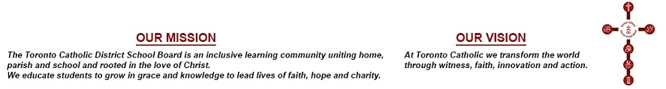
MINUTES OF THE CATHOLIC EDUCATION AND LIVING OUR CATHOLIC VALUES SUB-COMMITTEE MEETING
PUBLIC SESSION

TUESDAY, MAY 21, 2019

Trustees: T. Lubinski, Chair
G. Tanuan, Vice-Chair
N. Crawford
M. Del Grande
M. Rizzo

Staff: M. Caccamo
L. Di Marco

S. Tomaz, Recording Secretary

External Member: N. Milanetti, Ontario Catholic School Trustees’ Association (OCSTA)

Call To Order
Trustee Tanuan declared a Point of Order regarding the convening of the meeting, based on the following Motion from the April 21, 2019 Sub-Committee Meeting.

The meeting is subject to Fr. Mark’s and Brian O’Sullivan’s availability.

The Chair ruled in favour of Trustee Tanuan’s Point of Order.

Trustee Rizzo challenged the Chair.

Results of the Vote taken on the Chair’s Ruling, as follows:

In Favour Opposed

Trustees Del Grande Crawford
Lubinski Rizzo
Tanuan

The Chair’s Ruling was declared

CARRIED

The meeting dissolved at 3:42 pm.

Next meeting is scheduled for June 11, 2019 at 5 pm.

____________________________ | ________________________________
SECRETARY | CHAIR

