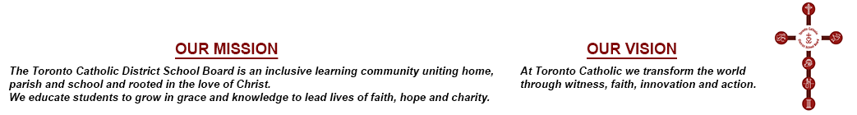
MINUTES OF THE SPECIAL MEETING
OF THE
TORONTO CATHOLIC DISTRICT SCHOOL BOARD
PUBLIC SESSION
HELD TUESDAY, JANUARY 8, 2019

PRESENT:

Trustees: M. Del Grande, Acting Chair
- Di Giorgio
N. Di Pasquale - via Teleconference
A. Kennedy – via Teleconference
I. Li Preti
T. Lubinski
M. Rizzo
G. Tanuan

Staff: R. McGuckin

S. Harris, Recording Secretary

3. Roll Call & Apologies
Apologies were received on behalf of Trustees Crawford, D’Amico, de Domenico and Martino.

MOVED by Trustee Rizzo, seconded by Trustee Tanuan, that all matters discussed in DOUBLE PRIVATE Session regarding the Toronto Catholic District School Board Director of Education Goals for 2018-19 be approved.

Results of the Vote taken, as follows:
In Favour Opposed
Trustees Del Grande
Di Giorgio
Di Pasquale
Kennedy
Li Preti
Lubinski
Rizzo
Tanuan

The Motion was declared

CARRIED

MOVED by Trustee Rizzo, seconded by Trustee Lubinski, that the meeting adjourn.

Results of the Vote taken, as follows:
In Favour Opposed
Trustees Del Grande
Di Giorgio
Di Pasquale
Kennedy
Li Preti
Lubinski
Rizzo
Tanuan

The Motion was declared

CARRIED

__________________________ | ________________________________
SECRETARY | CHAIR

